Timely Tips June 2018

I’d like to spend my time today answering QUESTIONS from previous meetings.

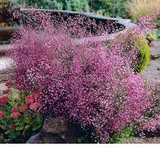
Is Thalictrum deer resistant?

YES! I found a very helpful list of deer resistant plants on the Rutgers website:
(https://njaes.rutgers.edu/deer-resistant-plants/). They use a letter rating scale: A = rarely damaged, B = seldom severely damaged, C-=occasionally severely damaged, and D= frequently severely damaged. Thalictrum is given an “A” = rarely damaged.

I forgot to have photos of blooming Thalictrum for you last month. I brought some along today. My own plant, which I tortured before getting it into the ground (kept forgetting to water it), is currently 5 feet tall and looking good. It should continue to grow even higher and will bloom in another few weeks.

Are impatiens safe to plant?

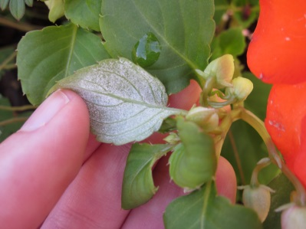
I don’t think so. The common garden impatiens - walleriania - is still in trouble. George Pouder discussed this subject in April of 2013. He described how downy mildew was the culprit killing off our favorite annual - “busy Lizzy”.

The Cooperative Extension believes that downy mildew continues to be prevalent and there is no known cure. If you must have impatiens both George and various websites suggest New Guineas, Sunpatiens, or the Bounce series. Other choices all together are: begonias, coleus, caladium, browallia, torenia, and fuschia.
I did a little further research and there is a project by Ball Horticultural in Chicago
and Keygene in Maryland that completed mapping the genome of impatiens, so
perhaps a genetically modified impatiens species will be able to survive the mildew.
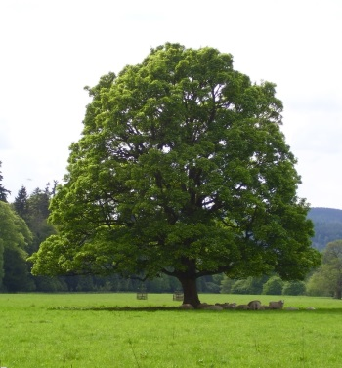
Have I ever heard of a buttonwood tree?

NO! But now I have.

A Buttonwood Tree is the common name for an American Sycamore (Platanus occidentalis). It is called the buttonwood because it can be milled without cracking and was used for shoe and clothing buttons, Native Americans made canoes from it, and now Sycamore is often found in butcher blocks.

The Buttonwood has historical significance because it was also the tree under which the NY Stock Exchange was formed. On May 17, 1792 at 68 Wall street 24 stockbrokers met under this tree and signed “The Buttonwood Agreement”, thus beginning our current Stock Exchange system.

The American sycamore is easily identified by its bark. Thus my helmet. The bark of a Sycamore reminds me very much of this type of army camouflage material. It CAN be confused with the London Plane Tree, which Robert Moses loved and planted throughout Central Park.

I brought some photos of various parts of the Sycamore. They really are remarkable trees for their massive size, hanging seed balls, and bark chunks that they throw off in late summer.

Could I expand on my Spotted Lanternfly comments; are they taking over?

No, they are not taking over - yet.

I spoke with Amy Albom from Cornell Cooperative Extension and she reiterated that the Lanternfly was found in PA in 2014 and has since been found in NJ, DE, and VA. In NY a dead bug was found in Delaware County last fall. (Delaware County is located in the southern part of the State, its northern edge runs along I-88, near Oneonta, Southern edge is the PA border created by the Delaware River. It is east of

Binghamton and southwest of Albany. The county contains part of the Catskill Mountains, too.)

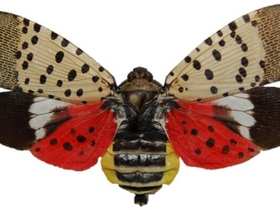
As of this spring, NY has no infestations. It IS expected to arrive here eventually. Amy said this could be a tough bug to stop because it lays eggs on stone and metal, and can easily be transported on gardening tools, lawnmowers, truck parts, etc.

And of course, she then mentioned a new “big thing” Jumping Worms. Oy.

Following along this same topic -

NY will be “celebrating” its fifth Invasive Species Awareness week from July 8-14. Saturday July 14th at 9 a.m. there will be an Invasive Species Identification Walk at Mianus Gorge. There are all sorts of organizations dealing with invasive species: the USDA, NY DEC, Cornell Cooperative Extension, Northeast Regional Invasive Species and Climate Change Management, PRISM = Partnerships for Regional Invasive Species Management, and loads more. The acronyms make my head spin. I’ll be sure to keep you posted as I find out any more information.

Thank you very much for your questions and interest. I hope you have a wonderful July 4th, and a very happy summer. I’ll see you in September.

